Project Design Phase-II
Technology Stack (Architecture & Stack)

Date | 16 February 2026
Team ID | LTVIP2026TMIDS87366
Project Name | Prosperity Prognosticator: Machine Learning for Startup Success Prediction
Maximum Marks

Technical Architecture:
The proposed system consists of a web interface where users enter startup details. The input is processed by the Flask application, which acts as the backend logic layer. The backend communicates with the trained machine learning model stored locally as a serialized file. The model processes the input and generates prediction results, which are displayed back to the user through the web interface. The system runs on a local server environment and does not depend on external APIs or cloud databases.

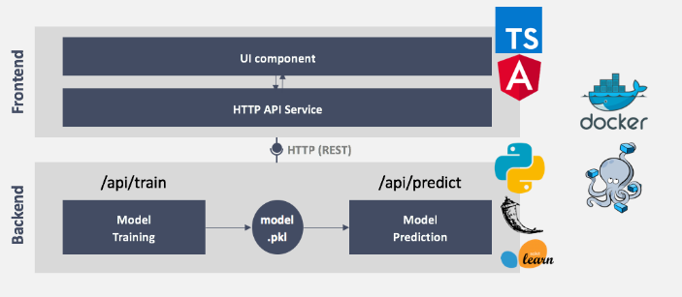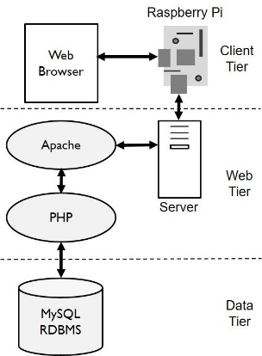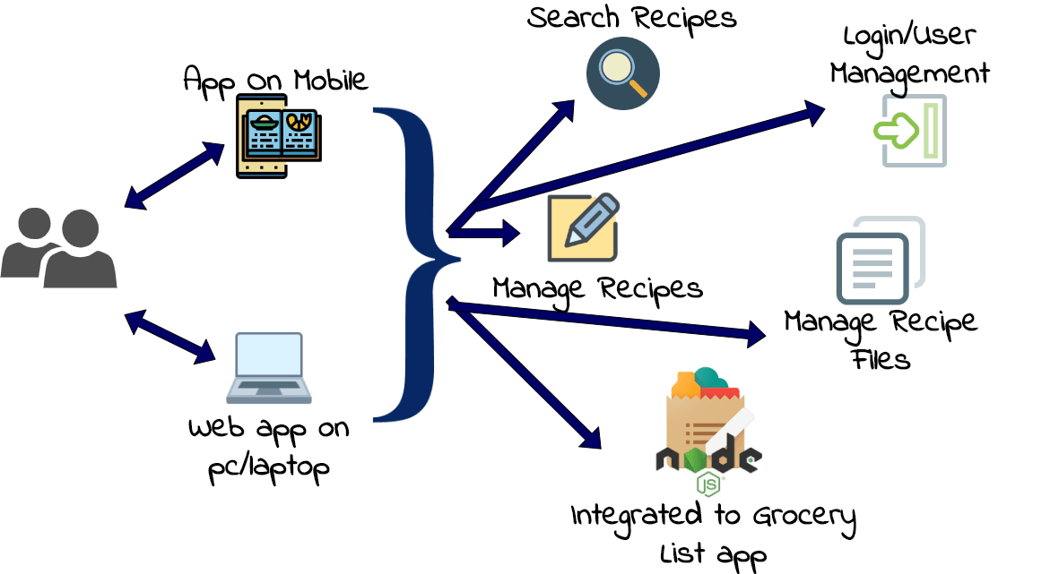

Figure: Technical Architecture of Startup Prediction System
Table-1 : Components & Technologies:

S.No | Component | Description | Technology
 | User Interface | Web interface where user enters startup details. | HTML, CSS, JavaScript
 | Application Logic-1 | Backend processing of user inputs | Python, Flask
 | Application Logic-2 | Data preprocessing and prediction logic | Pandas, NumPy, Scikit-learn
 | Application Logic-3 | Machine learning prediction workflow | Random Forest Classifier
 | Database | Dataset used for model training | CSV Dataset
 | Cloud Database | Not used in this project | Not Applicable
 | File Storage | Storage of trained model file and database | Local file sytstem
 | External API-1 | No external API used | Not Applicable
 | External API-2 | No external API used | Not Applicable
 | Machine Learning Model | Predict startup success | Random Forest Model (.pkl file)
 | Infrastructure (Server / Cloud) | Application runs on local server environment | Local, Cloud Foundry, Kubernetes, etc.

Table-2: Application Characteristics:
S.No | Characteristics | Description | Technology
 | Open-Source Frameworks | Open-source tools used for development | Python, Flask, Scikit-learn
 | Security Implementations | Basic input validation and secure processing | Flask validation, Python checks
 | Scalable Architecture | System allows model replacement and feature addition | Modular Flask architecture
 | Availability | Application available whenever local server runs | Local Hosting
 | Performance | Prediction generated quickly after input submission | Random Forest model, optimized dataset

References:
https://c4model.com/
https://developer.ibm.com/patterns/online-order-processing-system-during-pandemic/
https://www.ibm.com/cloud/architecture
https://aws.amazon.com/architecture
https://medium.com/the-internal-startup/how-to-draw-useful-technical-architecture-diagrams-2d20c9fda90d

